AP Calc WS#12 Derivative Exponent and Log Name: ______

Properties of Exponents and Logarithms

Product of Powers: _____________________ Log of a product: _______________

Quotient of Powers: _____________________ Log of a quotient: _______________

Power of Powers: _____________________ Log of a power: _______________

Converse between logarithms and exponents ___________________________

Formula $\frac{d}{dx}e^{x}=e^{x}$ $\frac{d}{dx}a^{x}=a^{x}ln(a)$ Note: Apply for chain rule $\frac{d}{dx}ln(x)=\frac{1}{x}$ $\frac{d}{dx}\log_{a}x=\frac{1}{xln(a)}$ 
 as well.

1. Fin the derivative of the followings

y = 2ex y = e2x y = e-x

y ' = y ' = y' =

y = e -x/4 y = e x + x^2 y = x2ex – xex

y' = y' = y ' =

y = 8x y = 9 -x y = 3 cscx

y' = y' = y' =

2. At what point on the graph of the function y = 2x – 3 does the tangent line have slope 21?

3. y = ln (x2) y = (ln x)2 y = ln (1/x)

y ' = y' = y' =

y = ln (ln x) y = x ln(x) – x y = ln (x2 + 1)

y ' = y' = y' =

4. A line with slope m passes through the origin and is tangent to line y = ln (x/3).

What is the value of m?

5. y = y = y =

y ' = y ' = y ' =

6. Logarithmic Differentiation (i.e. take ln both sides) Find the derivative of

y = (x3 + 4) cos x

7. If , find f '(x)

8. The spread of a flu in a certain school is modeled by the equation

$F(t)=\frac{100}{1+e^{3-t}}$ where F(t) is the total number of students infected t days after the flu is first noticed. Many of them may be well again at the time t.

a. Estimate the initial number of students infected with the flu.

b. How fast is the flu spreading after 3 days?

c. When will the flu spread at its maximum rate? What is this rate?

9. **Which is Bigger**, πe or eπ? (Remember both numbers are never ended). Calculators have taken some of the mystery out of this once-challenging question. (Go ahead and check; you will see that it is a surprisingly close call.) Now without a calculator, we will solve this mystery by following these steps

a. Find the tangent line of function f(x) = ln x

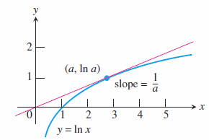

b. Which is bigger? $lnx$ or $\frac{x}{e}$

c. Which is bigger? $lnx^{e}$ or $x$

d. Which is bigger? $x^{e}$ or $e^{x}$

e. Let x = π then?

10. Prove that all curves in the family $y=\frac{-1}{2}x^{2}+k$

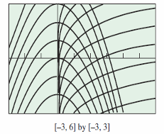(k any constant) are perpendicular to all curves in the

family y = ln (x) + c (c any constant) at their points of intersection.